Date: 19 April 2025
To: GCS Maritime Agency
Port: Offshore Lome , Togo
Subject : LETTER OF AUTHORITY FOR THE FRESH WATER DELIVERY

Dear Sirs,
Please be advised that I authorized the GCS MARITIME to arrange the following for my vessel MT ‘SEA PHANTOM’ while at Offshore Lome, Togo anchorage:

- DELIVERY OF FRESH WATER

I also authorized service craft to approach my vessel for the delivery of same.
This LOA also serves as clearance for the said operations.

GCS Maritime Agency arrange all formalities for the above operation

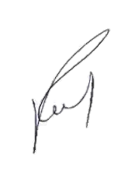
Print name: Capt. Tengiz Kilasonia
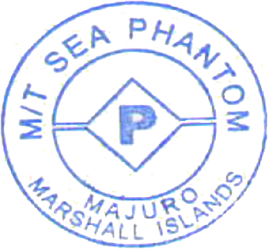
Master of ” MT SEA PHANTOM

